**Topic: Pythagoras Theorem**

Time: 45 mins Marks: /45 marks

**Calculator Assumed**



**Question One: [2, 2, 4: 8 marks]**

Calculate the value of the unknown in each of the following triangles.

a)



b)



c)

**Question Two: [4, 4: 8 marks]**

a) Cadel is going for a casual Sunday cycle. He cycles 20 km due north and stops to have a coffee at a café. Then he cycles 17 km due west to practice his sprints. He then returns directly back home.

i) Draw a diagram to show Cadel’s cycle path.

ii) Calculate his total distance traveled.

b) Aimee is sewing a pillow case. She has a rectangular piece of material but she accidentally cut it along the diagonal to make two triangles. The material is 30 cm wide and her cut along the diagonal measures 41 cm.

i) Draw a diagram to represent this situation.

ii) Calculate the total area of the original rectangular piece of material.

**Question Three: [5 marks]**

The surface area of the square based tent shown below, including the ground sheet is 4.7 m2.

Calculate the height of the centre support pole.



**Question Four: [2, 6, 2: 10 mark]**

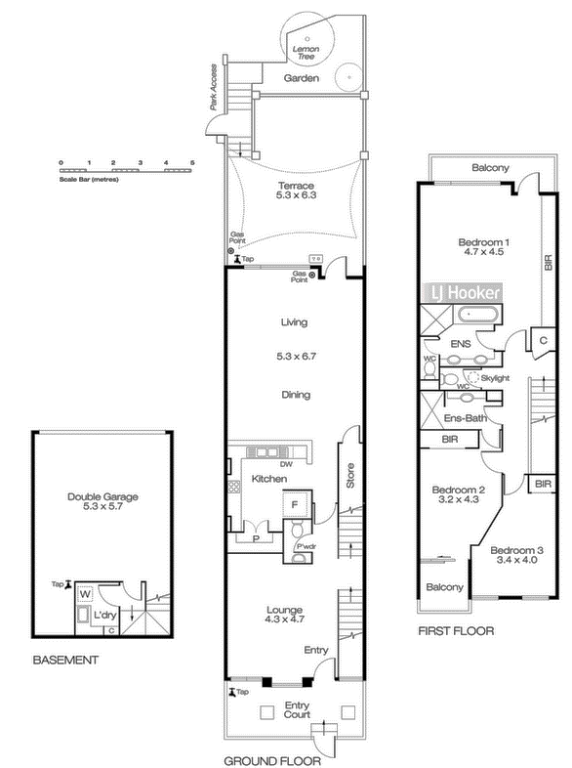A building developer has purchased a large stretch of land. The block has 100 m street frontage. The developer plans to build a series of long skinny townhouses alongside each other. Below is the basic shape of each townhouse and the 3 storey floor plan.



a) How many townhouses will fit alongside each other on this block of land, with no gaps between houses?

b) Council regulations state that for this design the slant height of the roof needs to be no more than 3.7 m and no less than 3 m. Calculate the maximum and minimum lengths of the vertical strut which will satisfy this design.

c) The roof goes from the front of bedroom 3 (on the first floor) to the furthest point on bedroom 1 (on the first floor). The roof does not cover the balconies. If the sloping sides of the roof are to be tiled (not the front and back), calculate the surface area which is to be tiled for the townhouse with the minimum slant height.

**Question Five: [5, 5, 5: 15 marks]**

****Aqua Delux swimming pools all have the same basic design as shown in the diagram below. Their design is fairly standard and most aspects are fixed. All of their pools are rectangular in shape and are 3 m by 7 m. They all have a shallow end which is always 0.9 m deep and the slope from the shallow end to the deep end is always of the length of the pool. Where the pools may vary in their design is in the depth of the deep end. The minimum depth of the deep end is 1 m.

a) Calculate the volume of water in the pool when the deep end is 2 m deep.

b) If the volume of water in a particular pool design is 36.5 m3, what is the depth of the deep end of the pool?

c) The slope from the shallow end to the deep end is tiled in a fancy pattern. Calculate the surface area which is to be tiled for a pool with a deep end of 1m deep.

**Pythagoras Theorem SOLUTIONS**

Time: 45 mins Marks: /45 marks

**Calculator Assumed**



**Question One: [2, 2, 4: 8 marks]**

Calculate the value of the unknown in each of the following triangles.

a)







$x^{2}={11}^{2}+{15}^{2}$

$$x=18.60 cm$$

b) ${ 32}^{2}=x^{2}{+19}^{2}$



$x=25.75 cm$

c)







${20}^{2}={16}^{2}+{\left(2x-9\right)}^{2}$

$$x=10.5$$

One answer only

**Question Two: [4, 4: 8 marks]**

a) Cadel is going for a casual Sunday cycle. He cycles 20 km due north and stops to have a coffee at a café. Then he cycles 17 km due west to practise his sprints. He then returns directly back home.

i) Draw a diagram to show Cadel’s cycle path.



ii) Calculate his total distance traveled.

b) Aimee is sewing a pillow case. She has a rectangular piece of material but she accidentally cut it along the diagonal to make two triangles. The material is 30 cm wide and her cut along the diagonal measures 41 cm.

 i) Draw a diagram to represent this situation.



ii) Calculate the total area of the original rectangular piece of material.



$${41}^{2}=x^{2}{+30}^{2}$$

$$x=27.95 cm$$

$$A=30×27.95$$

$$=838.39{ cm}^{2}$$

**Question Three: [6 marks]**

The surface area of the square based tent shown below, including the ground sheet is 4.7 m2.

Calculate the height of the centre support pole.





 *~~x~~* ~~= -4.6178~~ *~~m~~*



**Question Four: [2, 4, 2: 8 mark]**

A building developer has purchased a large stretch of land. The block has 100 m street frontage. The developer plans to build a series of long skinny townhouses alongside each other. Below is the basic shape of each townhouse and the 3 storey floor plan.



a) How many townhouses will fit alongside each other on this block of land, with no gaps between houses?

Using the scale, the front of the house measures 5m, therefore 20 townhouses would fit along the block.

b) Council regulations state that for this design the slant height of the roof needs to be no more than 3.7 m and no less than 3 m. Calculate the maximum and minimum lengths of the vertical strut which will satisfy this design.



${3.7}^{2}={2.5}^{2}+x^{2}$

$x=7.44 m$ (maximum)

 and

$$3^{2}={2.5}^{2}+x^{2}$$

$$x=2.75 m (minimum)$$

c) The roof goes from the front of bedroom 3 (on the first floor) to the furthest point on bedroom 1 (on the first floor). The roof does not cover the balconies. If the sloping sides of the roof are to be tiled (not the front and back), calculate the surface area which is to be tiled for the townhouse with the minimum slant height.



**Question Five: [5, 5, 5: 15 marks]**

****Aqua Delux swimming pools all have the same basic design as shown in the diagram below. Their design is fairly standard and most aspects are fixed. All of their pools are rectangular in shape and are 3 m by 7 m. They all have a shallow end which is always 0.9 m deep and the slope from the shallow end to the deep end is always of the length of the pool. Where the pools may vary in their design is in the depth of the deep end. The minimum depth of the deep end is 1 m.

2 m

a) Calculate the volume of water in the pool when the deep end is 2 m deep.

Vol $=2×7×3-\left(1.1×\frac{14}{3}÷2×3\right)$

$$=42-\frac{77}{10}$$

$$=34.3 m^{2}$$

b) If the volume of water in a particular pool design is 36.5 m3, what is the depth of the deep end of the pool?

c) The slope from the shallow end to the deep end is tiled in a fancy pattern. Calculate the surface area which is to be tiled for a pool with a deep end of 1m deep.



